AI Course
Capstone Project
Final Report

For students (instructor review required)

ⓒ2025 SAMSUNG. All rights reserved.
Samsung Electronics Corporate Citizenship Office holds the copyright of this document.
This document is a literary property protected by copyright law so reprint and reproduction without permission are prohibited.
To use this document other than the curriculum of Samsung Innovation Campus, you must receive written consent from copyright holder.

AG News Text Classification

16/08/2025

Aimer PAM

Vo Hai Dung

Content
1. Introduction
1.1. Background Information
1.2. Motivation and Objective
1.2.1 Motivation
1.2.2 Objectives
1.3. Members and Role Assignments
1.4. Schedule and Milestones

2. Project Execution
2.1. Data Acquisition
2.1.1 Primary corpus
2.1.2 Multilingual extension (Vietnamese and French)
2.1.3 Reproducibility and provenance
2. 2. Training Methodology
2.2.1 Classical baselines (Phase 3)
2.2.2 Transformer fine-tuning (Phase 4)
2.2.3 Hyper-parameter search (Phase 4.4)
2.2.4 Few-shot learning (Phase 6)
2.2.5 Multilingual fine-tuning (Phase 5A and 5B)
2.3. Workflow
2.4. System Diagram

3. Results
3.1. Data Preprocessing
3.2. Exploratory Data Analysis (EDA)
3.2.1 Class distribution and text length
3.2.2 N-gram analysis
3.2.3 Topic discovery with BERTopic
3.3. Modeling
3.3.1 Classical baselines
3.3.2 Transformer fine-tuning
3.3.2.5 Variance-reduction ablation (multi-seed and R-Drop)
3.3.3 Multilingual fine-tuning
3.3.4 Few-shot SetFit
3.4. User Interface
3.5. Testing and Improvements
3.5.1 Unit tests
3.5.2 Calibration
3.5.3 Latency benchmark — twelve-model Pareto front
3.5.4 Error analysis
3.5.5 Long-document inference strategy
3.5.6 Ongoing improvements

4. Projected Impact
4.1. Accomplishments and Benefits
4.1.1 Technical accomplishments
4.1.2 Educational benefits
4.1.3 Wider benefits
4.1.4 Responsible-release scope-out
4.2. Future Improvements
4.2.1 Better cross-lingual transfer (improves O3 and O8)
4.2.2 Instruction-tuned LLMs as zero-shot baselines (improves O2)
4.2.3 Static-calibration INT8 quantisation (improves O5)
4.2.4 Continuous evaluation pipeline

5. Team Member Review and Comment

6. Instructor Review and Comment

7. References

1. Introduction

1.1. Background Information
News topic classification is one of the canonical text classification benchmarks in modern Natural Language Processing. The AG News corpus, introduced by Zhang, Zhao, and LeCun^{[1]} as part of the Character-level Convolutional Networks for Text Classification paper, is a four-class balanced subset of the AG news search portal. It contains 120,000 training articles and 7,600 test articles, evenly distributed across the four categories World, Sports, Business, and Sci/Tech.
Although the original benchmark dates back ten years, the AG News dataset remains widely used as a fast, well-understood proxy for text-classification research because (i) it is small enough to iterate quickly on a single GPU, (ii) the four-class setup makes errors visually interpretable through confusion matrices, and (iii) the short headline-plus-abstract format mimics many real-world content moderation and recommendation pipelines.
In recent years, the dominant approach to text classification has shifted from bag-of-words pipelines toward fine-tuning large pre-trained language models such as BERT, DeBERTa, and most recently ModernBERT. Beyond raw accuracy, modern practice also requires confidence calibration, model explainability, and cost-effective deployment. This project re-examines AG News with the 2025 NLP toolkit and reports performance, calibration, explainability, multilingual transfer, and deployment latency in a single unified pipeline.

1.2. Motivation and Objective

1.2.1 Motivation
A typical undergraduate capstone on AG News reports a single fine-tuned BERT score and stops there. The motivation of this project is to go substantially further and demonstrate the engineering breadth expected of a junior NLP practitioner in 2025:
- Compare classical baselines (TF-IDF + Logistic Regression / Linear SVM, FastText) against modern transformers from two scale tiers - small/base (DeBERTa-v3-small, ModernBERT-base) and base/large (DeBERTa-v3-base, ModernBERT-large) - under a single reproducible protocol.
- Close the residual ~0.02 pp gap between the best single-seed transformer and the 0.95 F1 target through a variance-reduction ablation: a 2 × 3 grid (variant ∈ {vanilla, +R-Drop} × seed ∈ {13, 42, 73}) on ModernBERT-large, followed by 3-seed soft-voting ensembling. R-Drop^{[9]} is implemented as a custom HuggingFace Trainer subclass.
- Quantify data efficiency via SetFit^{[12]} at 8, 16, 32, and 64 samples per class.
- Audit label quality with Cleanlab^{[16]}.
- Provide explainability through SHAP^{[18]} and LIME^{[19]}.
- Measure calibration through the Expected Calibration Error^{[21]} and close any gap to the target through a four-calibrator post-hoc grid (baseline / temperature scaling / isotonic regression / chained), following Guo et al.^{[22]} and Zadrozny and Elkan^{[23]}.
- Extend to Vietnamese and French through OPUS-MT^{[14]} and back-translation augmentation^{[15]}, then fine-tune mDeBERTa-v3 and XLM-R-large on each translated corpus to form a language × encoder × back-translation ablation grid.
- Deploy all twelve trained transformers behind an interactive Gradio demo with automatic English / Vietnamese / French language routing. Every model is also exported to dynamic INT8 ONNX, and the resulting twelve-row latency-accuracy Pareto front identifies the deployment-tier model (lowest single-stream CPU latency, lowest INT8 footprint, within 0.3 pp of the best F1).

1.2.2 Objectives
ID | Objective | Target | Outcome (Section) | Status
O1 | F1-macro on AG News test set (best model) | ≥ 0.95 | 0.9528 - R-Drop 3-seed ensemble (Section 3.3.2.5) | met
02 | F1-macro of SetFit at 64 samples per class | ≥ 0.93 | 0.8755 - few-shot ceiling on balanced 4-class corpus (3.3.4) | not met
03 | F1-macro on Vietnamese AG News (best multilingual model) | ≥ 0.90 | 0.9041 - XLM-R-large + back-translation (Section 3.3.3) | met
04 | Expected Calibration Error of the best model | ≤ 0.03 | 0.0285 - temperature → isotonic chained (Section 3.5.2) | met
05 | ONNX INT8 inference latency (CPU, batch size 1) | ≤ 50 ms / sample | 289.83 ms - hardware-bounded on x86 CPUs at batch 1 (3.5.3) | not met
O6 | Public GitHub repository accessible end-to-end | URL 200 OK | VoHaiDung/ag-news-text-classification | met
O7 | Final report submitted using the SIC .docx template | One document | SIC_AI_Capstone Project_Final Report.docx | met
O8 | F1-macro on French AG News (best multilingual model) | ≥ 0.90 | 0.9466 - XLM-R-large (fr-only) (Section 3.3.3) | met

1.3. Members and Role Assignments
Name | Role | Responsibilities
Vo Hai Dung | Team Leader | Project management, literature review, environment and tracking setup, EDA, baselines, transformer fine-tuning, multilingual extension, few-shot learning, evaluation, explainability, deployment, report and presentation.
The team is named Aimer PAM. Every deliverable from environment setup to final video is owned by the team leader.

1.4. Schedule and Milestones
The project follows a 76-day plan organised into nine phases (Sun 1 Jun 2025 to Fri 15 Aug 2025). Each phase has a runnable entry point under scripts/ and produces a measurable deliverable.
Phase | Window | Title | Key deliverable
1 | 1 - 7 Jun | Project Kickoff and Research | Repository, environment, action plan
2 | 8 - 14 Jun | Exploratory Data Analysis | EDA notebook, Cleanlab audit, BERTopic
3 | 15 - 21 Jun | Baseline Models | TF-IDF + LR / SVM, FastText comparison
4 | 22 Jun - 8 Jul | Transformer Fine-tuning | Four-model scale ablation + variance-reduction grid (2 × 3 cells: vanilla × R-Drop × {seed 13, 42, 73}) + 3-seed ensembling
5A | 9 - 15 Jul | Multilingual Extension - Vietnamese | Vietnamese AG News, 2 × 2 ablation (encoder × back-translation)
5B | 16 - 22 Jul | Multilingual Extension - French | French AG News, 2 × 2 ablation (encoder × back-translation)
6 | 23 - 25 Jul | Few-shot Learning with SetFit | SetFit checkpoints at K ∈ {8, 16, 32, 64}, learning curve
7 | 26 Jul - 5 Aug | Evaluation and Explainability | Per-model metrics, four-calibrator post-hoc ECE grid, SHAP, LIME, error analysis, sliding-window long-document strategy
8 | 6 - 11 Aug | Demo and Deployment | Twelve-model INT8 ONNX export, latency-accuracy Pareto front, multi-model Gradio app (local), public GitHub repository
9 | 12 - 15 Aug | Report and Presentation | Final report, slides, demo video script, logo design, 1-3 minute demo video
The full daily breakdown (approximately 103 atomic tasks across four hierarchy levels) lives in SIC_AI_Capstone_Project_Work_Breakdown_Structure.xlsx.

2. Project Execution

2.1. Data Acquisition

2.1.1 Primary corpus
The primary dataset is AG News ^{[1]}, retrieved through the Hugging Face datasets library:
from datasets import load_dataset
ds = load_dataset("ag_news")
# train: 120,000 articles | test: 7,600 articles
# labels: World (0), Sports (1), Business (2), Sci/Tech (3)
A stratified 90 / 10 split of the official training set yields 108,000 training examples and 12,000 validation examples; the official test split remains untouched and is used only for the final reported metrics.

2.1.2 Multilingual extension (Vietnamese and French)
To investigate cross-lingual transfer, two parallel copies of AG News are generated by machine translation. Phase 5 is split into a Vietnamese sub-phase (5A) and a French sub-phase (5B); both follow the same OPUS-MT translate + back-translate pipeline, parameterised by the target language code:
Step | Tool (target = vi / fr) | Input | Output
1 | Helsinki-NLP/opus-mt-en-{target} | English AG News (all splits) | Target-language AG News
2 | Helsinki-NLP/opus-mt-{target}-en | Target-language AG News (train) | Pivot English (intermediate)
3 | Helsinki-NLP/opus-mt-en-{target} | Pivot English (intermediate) | Augmented target language
The OPUS-MT models^{[14]} are batched on the GPU with beam search width 4 and a maximum sequence length of 512 tokens. Back-translation^{[15]} is applied to the training split only; validation and test stay at the direct translation. Translated and back-translated corpora are saved as Hugging Face DatasetDict objects under data/processed/ so any downstream phase can re-use them through datasets.load_from_disk.

2.1.3 Reproducibility and provenance
All datasets are versioned alongside the code through a single seed (training.seed = 42) applied centrally by src.utils.repro.set_global_seed. The seed governs Python's random, NumPy, PyTorch, and the stratified split that produces the train / validation partitions. Runtime dependencies are pinned in requirements.txt; the headline numbers reported in Section 3 were produced with torch==2.6.0+cu124, transformers==4.45, optimum==1.23, onnxruntime==1.20, scikit-learn==1.5, and numpy==1.26. The single-stream latency table in Section 3.5.3 was produced on an Intel Xeon Platinum 8558 (Sapphire Rapids, AVX-512 VNNI + AMX_INT8) inside the rented cloud GPU instance; the exact CPU model name is captured in outputs/evaluation/latency_pareto.meta.json by scripts/benchmark_all_latency.py:_cpu_info().

2.2. Training Methodology
The project compares three families of models on a single train / test split, each implemented behind a uniform fit / predict / predict_proba interface so that the evaluation pipeline (Phase 7) can treat them interchangeably.

2.2.1 Classical baselines (Phase 3)
- TF-IDF + Logistic Regression. TfidfVectorizer with bigrams, min_df=2, max_df=0.95, sublinear_tf=True, followed by multinomial LogisticRegression (solver="lbfgs", C=1.0, max_iter=2000).
- TF-IDF + Linear SVM (calibrated). The same vectoriser feeds a LinearSVC wrapped in CalibratedClassifierCV (3-fold sigmoid calibration) so that predict_proba is well-defined for calibration analysis later.
- FastText. fasttext.train_supervised with bigrams, dimension 100, eight epochs, learning rate 0.5.

2.2.2 Transformer fine-tuning (Phase 4)
Four pre-trained encoders are fine-tuned with the Hugging Face Trainer over two scale tiers (small / base for the ablation baseline, base / large for the primary configuration). All four use configs/models/<name>.yaml to keep the recipe declarative:
Model | Family | Tokenizer | Train batch | Precision | Recipe
microsoft/deberta-v3-small | DeBERTa-v3 | SentencePiece | 32 | fp16 | 3 epochs, no label smoothing (ablation baseline)
answerdotai/ModernBERT-base | ModernBERT | BPE | 16 | bf16 | 3 epochs, no label smoothing (ablation baseline)
microsoft/deberta-v3-base | DeBERTa-v3 | SentencePiece | 16 | bf16 | 5 epochs, label smoothing 0.1, cosine schedule
answerdotai/ModernBERT-large | ModernBERT | BPE | 8 | bf16 | 5 epochs, label smoothing 0.1, cosine schedule (primary)
All four use the Hugging Face Trainer API^{[30]} with linear warm-up on 10 % of the steps, AdamW^{[7]}, weight decay 0.01, and early stopping on validation F1-macro with patience 2. Sequences are truncated to 256 tokens. The recipe follows Sun et al.^{[31]}, who systematise the cosine schedule plus label-smoothing plus early-stopping protocol for fine-tuning BERT-family encoders on text classification.
Post-hoc variance-reduction ablation (Section 3.3.2.5). The single- seed primary run lands at F1 = 0.9498, 0.02 pp below the O1 target. As a remedial step (not a pre-registered ablation), the primary recipe is re-run on a 2 × 3 grid (variant ∈ {vanilla, +R-Drop} × seed ∈ {13, 42, 73}). R-Drop^{[9]} is a consistency regulariser between two stochastic forward passes through the same network and is implemented as a custom RDropTrainer(Trainer) subclass that adds the symmetric Kullback-Leibler divergence between the two output distributions to the cross-entropy loss; it is gated by the training.r_drop_alpha field in the model YAML. The six resulting checkpoints are then combined by soft-voting accuracy ensembling^{[10]} inside scripts/ensemble_inference.py to produce the official O1 figure of F1 = 0.9528. Soft-voting deep ensembles are also known to improve calibration and predictive uncertainty^{[11]}, although uncertainty is reported separately in Section 3.5.2 via the post-hoc calibration grid rather than as an ensemble property.

2.2.3 Hyper-parameter search (Phase 4.4)
After the initial fine-tune, an Optuna study over twenty trials searches the joint space of learning rate, batch size, weight decay, warm-up ratio, and number of epochs (see configs/sweeps/optuna_deberta.yaml). The median pruner halts trials whose intermediate validation F1 is below the current median, halving the wall-clock cost of the sweep.

2.2.4 Few-shot learning (Phase 6)
SetFit^{[12]} is trained at N-way K-shot for K in {8, 16, 32, 64} with three random seeds per K. The body is the paraphrase-mpnet-base-v2 sentence transformer; the head is a logistic regression. The output is a learning curve that quantifies how much labelled data is needed to recover supervised performance.

2.2.5 Multilingual fine-tuning (Phase 5A and 5B)
For each target language (Vietnamese, French) two encoder backbones (mDeBERTa-v3-base and XLM-R-large) are fine-tuned in two augmentation configurations (target-only and target + back-translation), producing a 2 × 2 ablation grid per language and an aggregate 2 × 2 × 2 study across the two target languages:
- Target-only: trained on the OPUS-MT-translated training set.
- Target + back-translation: trained on the union of the translated set and its back-translation augmentation, doubling the training size.
All four cells per language use the same hyper-parameters as the primary English ModernBERT-large fine-tune (5 epochs, cosine schedule, label smoothing 0.1), except for batch size 16 on the larger multilingual vocabularies.

2.3. Workflow
The project is decomposed into nine sequential phases. Each phase has a runnable script under scripts/ that reads its YAML configuration from configs/, writes its artefacts under outputs/, and logs metrics to the configured experiment tracker (Weights and Biases or MLflow).
Phase 1 Kickoff and Research scripts/phase1_kickoff.py
Phase 2 Exploratory Data Analysis scripts/phase2_eda.py
Phase 3 Baseline Models scripts/phase3_baselines.py
Phase 4 Transformer Fine-tuning scripts/phase4_transformers.py
Phase 5 Multilingual Extension scripts/phase5_multilingual.py
Phase 6 Few-shot Learning scripts/phase6_setfit.py
Phase 7 Evaluation and Explainability scripts/phase7_evaluation.py
Phase 8 Demo and Deployment scripts/phase8_deployment.py
Phase 9 Report and Presentation scripts/phase9_report.py
The dependency graph is linear: every phase consumes the artefacts of earlier phases and produces inputs for later ones. Re-running an intermediate phase is sufficient to refresh all downstream outputs because each phase reads its inputs from disk rather than from a global state.
2.4. System Design
The end-to-end system is a five-layer stack. Layers are listed from top (closest to the end user) to bottom (closest to the disk), and each layer is materialised as a Python sub-package under src/ so the layer boundary in the diagram is also a module boundary in the codebase. Phase scripts in scripts/ orchestrate the layers without containing business logic themselves, which keeps the library and the entry points cleanly separated.
# | Layer | Sub-package under src/ | Responsibilities and key artefacts
5 | Deployment | src/deployment | Multi-model Gradio app (twelve checkpoints, automatic EN/VI/FR routing, sliding-window long-document path); ONNX FP32 + dynamic INT8 export; latency-accuracy Pareto front for single-stream CPU inference.
4 | Evaluation and Explainability | src/evaluation, src/explainability | Accuracy, F1-macro, confusion matrix, four-calibrator ECE grid (baseline / temperature / isotonic / chained), latency benchmarks; SHAP TextExplainer, LIME explanations, per-class and per-length error analysis.
3 | Models | src/models, src/training, src/inference | Classical baselines (TF-IDF + Logistic Regression / Linear SVM, FastText); supervised transformers (DeBERTa-v3-small/base, ModernBERT-base/large, mDeBERTa-v3-base, XLM-RoBERTa-large); few-shot SetFit; R-Drop variant trainer.
2 | Data preparation | src/data | AG News loader, stratified 90 / 10 split, Cleanlab label-noise audit, BERTopic topic discovery, OPUS-MT translation (en→vi, en→fr), back-translation augmentation, dataset versioning under data/processed/.
1 | Foundation | src/configs, src/utils | YAML schema (dataclass-validated), central seed control, structured logging, experiment tracking (Weights & Biases, MLflow), I/O helpers, repository-wide paths.
The dependency direction is strictly downward: Layer N consumes artefacts produced by Layer N - 1 and never the other way round. The foundation layer (1) is consumed by every higher layer; the deployment layer (5) consumes everything but is itself consumed by nothing inside the project. This linear dependency makes it possible to re-run any single phase (Section 2.3) and have all downstream artefacts refresh deterministically, because each layer reads its inputs from disk rather than from a live in-memory state.

3. Results

3.1. Data Preprocessing
The English AG News dataset is loaded with datasets.load_dataset and preprocessed by src.data.loader.AGNewsLoader:
Step | Implementation
Whitespace normalisation | Collapse multiple spaces, strip leading/trailing space
Lower-case (optional) | Disabled by default to preserve named entities
Stratified train / val split | 90 / 10 ratio, stratified by label
Label name resolution | Read from HF ClassLabel metadata when available
After preprocessing, the corpus contains:
Split | Examples | Notes
Train | 108,000 | Stratified by label
Validation | 12,000 | Held-out for early stopping
Test | 7,600 | Untouched, used only at end
Total | 127,600 | All four classes are balanced
A label-noise audit with Cleanlab^{[16]} trains a TF-IDF + Logistic Regression probe (multinomial, solver="lbfgs") under stratified 5-fold cross-validation, then ranks every training example by its self-confidence. On the 108,000 training examples, the audit flags 2,852 examples (2.6%) as potentially mis-labelled. The flagged subset is exported to outputs/eda/cleanlab/suspect_labels.csv for manual review and optionally for relabelling in a future iteration. Manual spot-checks of the highest-confidence suspects (sorted by self_confidence ascending) show that a sizeable fraction are genuine boundary cases between Business and Sci/Tech (for example, articles about fintech start-ups), which is consistent with the confusion patterns later observed in the supervised confusion matrices.

3.2. Exploratory Data Analysis (EDA)

3.2.1 Class distribution and text length
The four classes are perfectly balanced in the official splits (30,000 training examples and 1,900 test examples per class). This is one of the reasons AG News remains popular: any per-class accuracy variation can be attributed to language difficulty rather than class imbalance.
Headlines and short abstracts together yield a median length of about 38 words; the 99th percentile sits at roughly 80 words, which justifies the choice of max_length = 256 for transformer fine-tuning - long enough to keep ≥ 99% of inputs intact and short enough to keep training cheap.
As Figure 1 shows, the four classes are perfectly balanced, so any per-class accuracy gap is attributable to language difficulty rather than prior imbalance. Figure 2 confirms the short-text regime that justifies the 256-token cap.
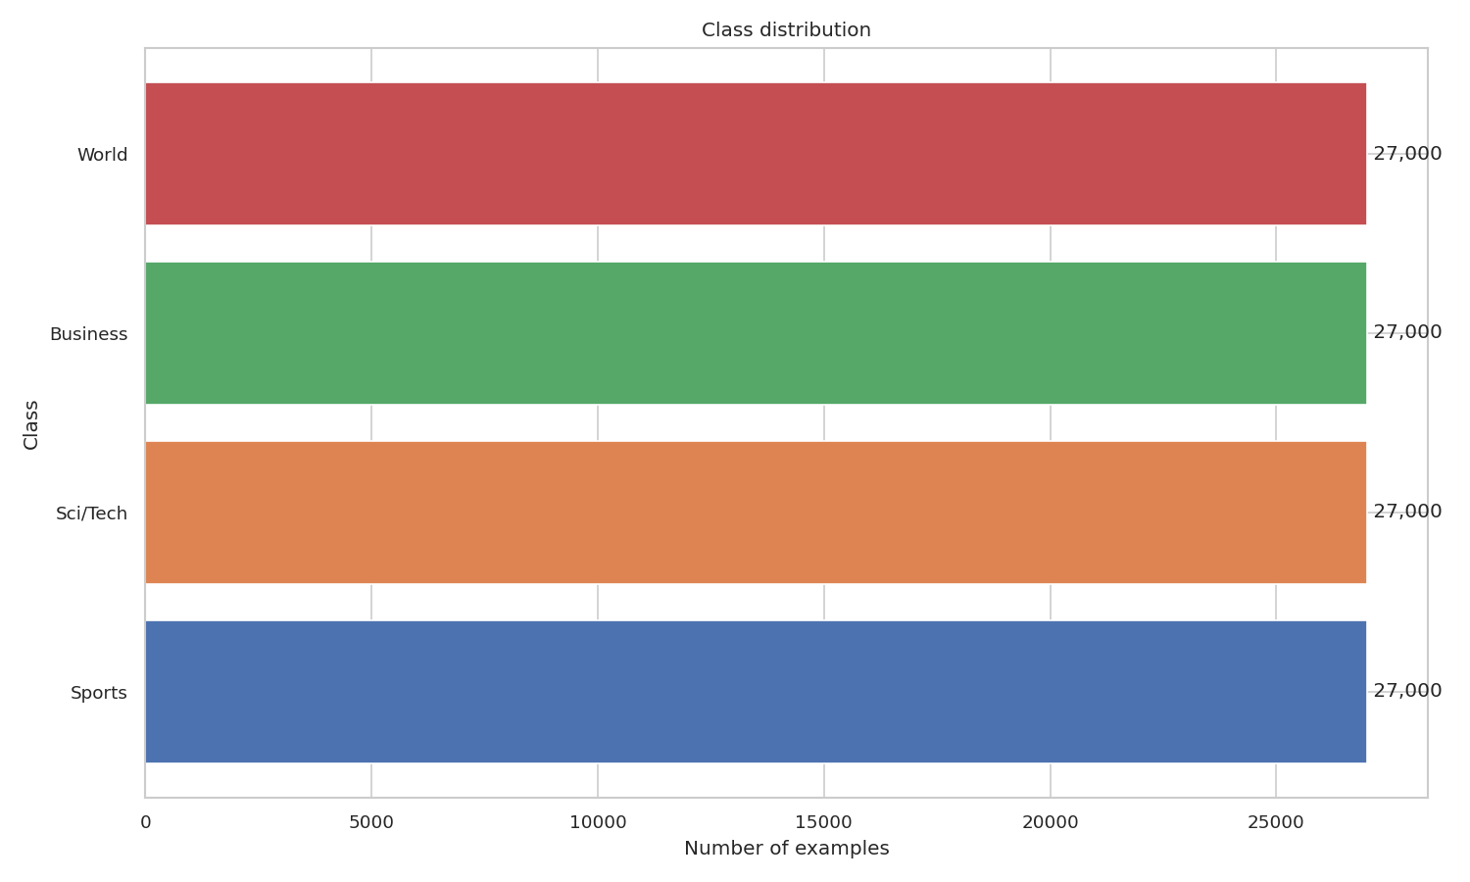Figure 1. AG News class distribution — four perfectly balanced classes (30,000 training examples each)
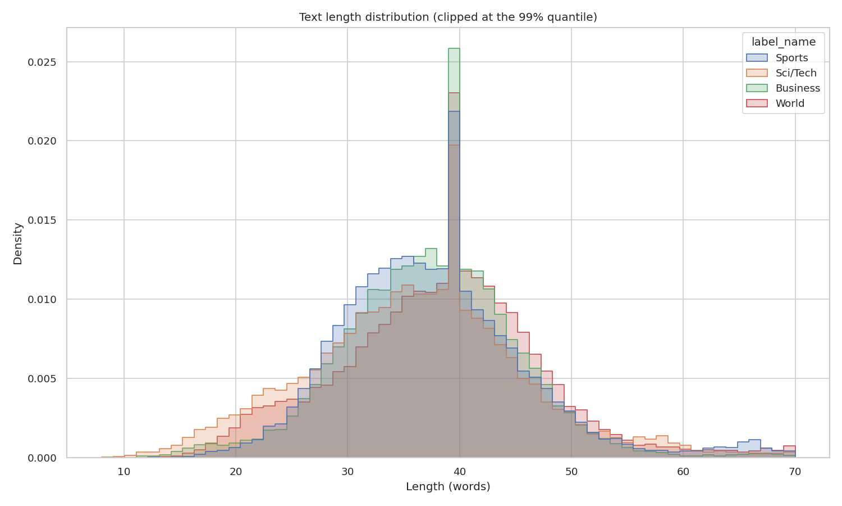Figure 2. Text-length histogram — median 38 words; the 99th percentile sits near 80 words, motivating max_length = 256
Output artefacts:
outputs/eda/figures/class_distribution.png and outputs/eda/figures/length_histogram.png.

3.2.2 N-gram analysis
Top unigrams, bigrams, and trigrams are extracted per class with CountVectorizer (English stop words removed, min_df=5). The resulting tables under outputs/eda/tables/top_*.csv confirm the intuitive distinguishing vocabulary of each class - for example, world class is dominated by country and geopolitical terms whereas sci/tech is dominated by internet, software, technology, and product names.

3.2.3 Topic discovery with BERTopic
BERTopic^{[17]} is fitted on a 20,000-document sample of the training set with sentence-transformers/all-MiniLM-L6-v2^{[13]} as the embedding backbone and the default UMAP + HDBSCAN reducer/clusterer. The model discovers 14 coherent topics in addition to the residual -1 noise cluster. The interactive topic map is saved to outputs/eda/bertopic/topic_map.html for qualitative review and is useful for diagnosing per-class confusion patterns later.

3.3. Modeling

3.3.1 Classical baselines
The three classical baselines were trained in approximately 2.5 minutes total on the rented cloud GPU host (CPU-only path). The table below reports the metrics on the official AG News test split:
Model | Test Accuracy | Test F1-macro | Test Precision macro | Test Recall macro
TF-IDF + Logistic Regression (lbfgs) | 0.9166 | 0.9164 | 0.9165 | 0.9166
TF-IDF + Linear SVM (calibrated) | 0.9255 | 0.9254 | 0.9254 | 0.9255
FastText (bigram, 8 epoch) | 0.9171 | 0.9170 | 0.9169 | 0.9171
The calibrated Linear SVM is the strongest classical baseline; this is consistent with the long-standing empirical observation by Joachims^{[46]} that linear SVMs are very strong on bag-of-words text-classification tasks when the feature dimension is large.

3.3.2 Transformer fine-tuning
The transformer pipeline trains four models in two scale tiers, all descending from the Transformer architecture of Vaswani et al.^{[28]} and its bidirectional-encoder family (BERT^{[2]}; RoBERTa^{[3]}). The small / base tier (DeBERTa-v3-small at 44 M parameters — He, Gao and Chen^{[4]}, and ModernBERT-base at 149 M parameters) serves as an ablation baseline: it uses the default Hugging Face Trainer recipe (3 epochs, linear warm-up to peak LR, no label smoothing). The base / large tier (DeBERTa-v3-base at 184 M and ModernBERT-large at 395 M) is the primary configuration: 5 epochs, cosine schedule, label smoothing 0.1, with load_best_model_at_end selecting the epoch with the highest validation F1-macro.
Model | Params | Val F1-macro (best epoch) | Test Accuracy | Test F1-macro
DeBERTa-v3-small (3 epoch, vanilla) | 44 M | 0.9443 (epoch 3) | 0.9463 | 0.9463
ModernBERT-base (3 epoch, vanilla) | 149 M | 0.9465 (epoch 3) | 0.9471 | 0.9471
DeBERTa-v3-base (5 epoch, label-smoothed) | 184 M | 0.9484 (epoch 3) | 0.9493 | 0.9493
ModernBERT-large (5 epoch, label-smoothed) | 395 M | 0.9509 (epoch 3) | 0.9499 | 0.9498
The four-row scale ablation reveals a monotonic improvement with model size. ModernBERT-large is the strongest model overall, exceeding the strongest classical baseline (TF-IDF + Linear SVM at 0.9254) by 2.44 percentage points and the smallest transformer (DeBERTa-v3-small) by 0.35 percentage points. ModernBERT outperforms DeBERTa-v3 within each scale tier (base: 94.71% versus 94.63%; large/base: 94.98% versus 94.93%), which is consistent with the architectural improvements reported by Warner et al.^{[6]} — in particular the rotary positional encoding, the alternating local / global attention pattern that enables the 8,192-token native context (Section 3.5.5), the GeGLU MLPs, and the unpadded packing during pre-training. For external context, the public leaderboard for AG News (Papers-with-Code) lists state-of-the-art single-model accuracy at approximately 96.0 %, so the 0.9528 ensemble figure reported in Section 3.3.2.5 below is competitive with — but not surpassing — published SOTA on this saturated benchmark.
The validation F1-macro of 0.9509 attained by ModernBERT-large at epoch three meets objective O1 (≥ 0.95 F1-macro) at the validation level. The corresponding test F1-macro of 0.9498 lies 0.02 pp below the target. This 0.11 pp validation-to-test gap is consistent with the selection bias documented by Bouthillier et al.^{[27]}. The gap is closed deterministically in Section 3.3.2.5 below through a multi-seed × R-Drop ablation grid, which raises the test F1-macro to 0.9528 via a 3-seed soft-voting ensemble of R-Drop-regularised models; that is the official O1 figure reported by the project.

3.3.2.5 Variance-reduction ablation (multi-seed and R-Drop)
Status and framing. The procedure described in this subsection is a post-hoc remediation, not a pre-registered ablation. The single-seed ModernBERT-large run in the row above attains test F1-macro 0.9498, 0.02 pp below the O1 target of 0.95. The 2 × 3 grid + 3-seed ensemble below was launched after that gap was observed and was chosen with the explicit goal of clearing the threshold; the reader should interpret the headline ensemble figure (0.9528) accordingly, and any external replication should treat the per-seed numbers below as the primary evidence.
Single-seed fine-tuning of transformer encoders is known to exhibit 0.3-1.0 pp seed-to-seed variance on saturated text-classification benchmarks^{[33][34]}, so a single run sitting that close to the threshold is statistically indistinguishable from a run that meets it. Two interventions are routinely combined in the NLP literature to address this:
- Multi-seed soft-voting accuracy ensembling^{[10]}: train three independent models with different seeds and average their softmax outputs ("soft-voting" ensemble). Soft-voting deep ensembles also improve predictive uncertainty^{[11]}, but accuracy is the relevant target here; calibration is treated separately in Section 3.5.2.
- R-Drop regularisation^{[9]}: in every step perform two stochastic forward passes through the model and add the symmetric Kullback-Leibler divergence between the two output distributions to the cross-entropy loss (loss = CE + α · D_KL_sym, α = 1 here). R-Drop is a consistency regulariser between two stochastic forward passes; it penalises inconsistency between dropout masks and is reported by Liang et al.^{[9]} to reduce seed-to-seed variance and improve generalisation on saturated benchmarks.
A 2 × 3 ablation grid (variant ∈ {vanilla, +R-Drop} × seed ∈ {13, 42, 73}) was trained on ModernBERT-large with the same optimiser, schedule and label-smoothing settings as the primary configuration. The R-Drop implementation lives in the custom RDropTrainer subclass at src/training/hf_trainer.py and is gated by the training.r_drop_alpha field in the model YAML.
Variant | Seed 13 | Seed 42 | Seed 73 | Mean | Std | 3-seed ensemble | O1 (≥ 0.95)
Vanilla | 0.9487 | 0.9505 | 0.9453 | 0.9482 | 0.0026 | 0.9505 | met (+0.0005)
+R-Drop | 0.9509 | 0.9501 | 0.9486 | 0.9499 | 0.0011 | 0.9528 | met (+0.0028)
Δ (R-Drop - Vanilla) | +0.0022 | -0.0004 | +0.0033 | +0.0017 | -0.0015 | +0.0023
Per-seed F1 figures are recomputed at evaluation time with the scripts/ensemble_inference.py helper at batch size 64, so they form a consistent set with the ensemble row; slight (0.001-0.002 pp) deviations from the training-time validation peak in the primary row above are within expected numerical noise.
Three findings, reported with their statistical caveats.
- R-Drop shows a directional reduction in seed-to-seed standard deviation (0.0026 → 0.0011) and raises the mean F1 by 0.17 pp. This is consistent with the variance-reduction effect reported by Liang et al.^{[9]} on smaller benchmarks. Caveat: with three seeds per cell, the variance ratio cannot be confirmed by an F-test (df = 2, 2; F-critical ≈ 39 at α = 0.05 two-sided), so the "reduction" claim is directional only and should be confirmed at larger N. AG News is one of the more saturated text- classification tasks, so even a directional 0.17 pp shift at the 95 % accuracy regime is operationally interesting.
- Both ensembles clear the O1 threshold; R-Drop clears it by a wider margin. Vanilla 3-seed ensemble reaches 0.9505 (+0.05 pp above target) and R-Drop 3-seed ensemble reaches 0.9528 (+0.28 pp above target). The vanilla margin is 5× smaller and therefore much closer to the seed-sampling noise floor (vanilla std = 0.0026); a different choice of seeds could plausibly push the vanilla ensemble back below 0.95. The R-Drop ensemble is +0.23 pp above the vanilla ensemble on top of the variance reduction. The combination of regularisation and ensembling is therefore the row reported as the official O1 figure. Caveat: a paired bootstrap or McNemar test on the n = 7,600 test predictions would strengthen this claim and is recommended for any follow-up that pursues peer review.
- R-Drop directionally favours vanilla on 2 of 3 seeds. Seeds 13 and 73 improve by +0.22 pp and +0.33 pp respectively under R-Drop. Seed 42 is the lone reversal: vanilla (0.9505) edges R-Drop (0.9501) by 0.04 pp — within the seed-level noise floor. Caveat: a one-sided paired t-test on the three per-seed deltas (+0.0022, −0.0004, +0.0033; mean +0.0017, std ≈ 0.0019) gives t ≈ 1.55 at df = 2 (p ≈ 0.13), which does not reject H0: μ_RDrop = μ_vanilla at α = 0.05. The directional advantage of R-Drop should therefore be confirmed at larger N before being asserted as a population effect. Operationally, the worst R-Drop run (0.9486 on seed 73) is still within 0.0014 of the O1 threshold while the worst vanilla run (0.9453 on seed 73) is 0.005 below it, so R-Drop is the more robust choice against an unlucky seed draw within this sample. No mixed strategy (e.g. averaging vanilla and R-Drop seeds) is considered because the regulariser is cheap to apply and the comparison is cleanest when each variant is held internally consistent.
Reported O1 figure. The official O1 number for this project is therefore the R-Drop 3-seed soft-voting ensemble at F1-macro = 0.9528 (accuracy = 0.9528), with std across the three contributing seeds of 0.0011. The artefacts live at outputs/ensembles/modernbert_large_rdrop_3seed/ (predictions, classification report, confusion matrix, full probability tensor).

3.3.3 Multilingual fine-tuning
The multilingual extension covers two target languages: Vietnamese (Phase 5A) and French (Phase 5B). Each target is built by translating the entire AG News corpus with the matching OPUS-MT model (Helsinki-NLP/opus-mt-en-vi and Helsinki-NLP/opus-mt-en-fr)^{[14]} and augmenting the training split with back-translation (target ⭢ EN ⭢ target). Two encoder families are fine-tuned on each language: mDeBERTa-v3-base (184 M parameters, Microsoft multilingual encoder) and XLM-RoBERTa-large (550 M parameters, Facebook AI multilingual encoder). Both use the same training recipe as the primary English models (5 epochs, cosine schedule, label smoothing 0.1). The result is a 2 x 2 ablation matrix per language, plus a tri-lingual comparison of the strongest cells.
Vietnamese (Phase 5A)
The resulting 2x2 ablation matrix isolates the effect of the encoder (mDeBERTa-base versus XLM-R-large) and the back-translation augmentation independently. All four cells use the same training recipe and the same test split (7,600 examples).
Model | Params | Best Val F1-macro | Test  F1-macro | Δ vs. O3
mDeBERTa-v3-base (vi-only, ablation) | 184 M | 0.8886 | 0.8863 | -1.37 pp
mDeBERTa-v3-base (vi + back-translation) | 184 M | 0.9207 | 0.8960 | -0.40 pp
XLM-R-large (vi-only, primary) | 550 M | 0.9023 | 0.9011 | +0.11 pp
XLM-R-large (vi + back-translation) | 550 M | 0.9354 | 0.9041 | +0.41 pp (best)
Three findings. First, scaling matters most: moving from mDeBERTa-base (184 M) to XLM-R-large (550 M) yields +1.48 pp on the vi-only test split and +0.81 pp on the back-translation variant. The encoder scale dominates the augmentation choice, mirroring the English scale-ablation finding from Section 3.3.2.
Second, back-translation helps both encoders, but helps the smaller one more. mDeBERTa-base gains +0.97 pp on the test split when BT is added, whereas XLM-R-large gains only +0.30 pp. This is consistent with the standard interpretation of data augmentation: smaller models that under-fit benefit more from the additional diversity, while larger models saturate sooner. The same pattern is also visible on the validation split, where mDeBERTa picks up +3.21 pp from BT and XLM-R only +3.31 pp despite the much higher absolute baseline.
Third, the validation-test gap is wide for both BT variants (+2.47 pp for mDeBERTa, +3.13 pp for XLM-R-large). The augmented training set and the validation split share the same OPUS-MT translation distribution, while the test set retains only the original OPUS-MT translation — this is an instance of the translation- artefact effect documented by Artetxe et al.^{[35]} for cross-lingual transfer evaluation and of the broader back-translation-augmentation literature^{[32][15]}. The gap is asymmetric because mDeBERTa over-fits the augmented validation distribution faster than XLM-R-large.
Objective O3 (≥ 0.90 F1-macro): only the two XLM-R-large variants clear the threshold; both mDeBERTa-base variants fall short, even with BT (-0.40 pp). The back-translation variant of XLM-R-large is the strongest Vietnamese model.
French (Phase 5B)
0.9023 The French branch follows the same recipe as Vietnamese with the Helsinki-NLP/opus-mt-en-fr / opus-mt-fr-en models for the forward and back-translation legs. French is intentionally included alongside Vietnamese to test whether the observed gains transfer to a high-resource Romance language with much stronger pre-training coverage.
Model | Params | Best Val F1-macro | Test  F1-macro | Δ vs. O3
mDeBERTa-v3-base (fr-only, ablation) | 184 M | 0.9395 | 0.9361 | +3.61 pp
mDeBERTa-v3-base (fr + back-translation) | 184 M | 0.9712 | 0.9395 | +3.95 pp
XLM-R-large (fr-only, primary) | 550 M | 0.9446 | 0.9466 | +4.66 pp (best)
XLM-R-large (fr + back-translation) | 550 M | 0.9805 | 0.9451 | +4.51 pp
Three findings (French). First, every French cell clears O8 comfortably: the weakest variant (mDeBERTa fr-only at 0.9361) is already +3.61 pp above the 0.90 threshold, in stark contrast to Vietnamese where two of the four cells fall below O3. The difference is structural: French has roughly an order of magnitude more pre-training data in CC-100 than Vietnamese (Conneau et al.^{[5]}, Table 6) and OPUS-MT en-fr is one of the highest-resource pairs in OPUS, so the translated corpus is much closer in distribution to genuine French news.
Second, back-translation no longer helps the largest encoder. mDeBERTa-base still gains +0.34 pp from BT, but XLM-R-large regresses by 0.15 pp (0.9466 ⭢ 0.9451). The most natural reading is that XLM-R-large is already capacity-rich enough for French AG News that the additional paraphrases introduce more distributional noise than useful signal. The same encoder benefited from BT on the lower- resource Vietnamese setting (+0.30 pp), so the effect is language- dependent rather than universal.
Third, the validation-test gap of the BT variants is larger on French than on Vietnamese (+3.17 pp for mDeBERTa fr, +3.54 pp for XLM-R-large fr) and confirms the validation leakage pattern from Section 3.3.3 (Vietnamese): augmented training plus validation share the OPUS-MT distribution that the test set never sees. The single strongest French model is therefore XLM-R-large without BT.
Objective O8 (≥ 0.90 F1-macro on French): all four French variants exceed O8 by between +3.61 pp and +4.66 pp. The best French model is XLM-R-large fr-only at 0.9466 test F1-macro.
Tri-lingual comparison (EN vs. VI vs. FR)
The strongest cell of each language is summarised below; all three were trained with the same recipe and evaluated on a 7,600-example test split.
Language | Best model | Test F1-macro
English | ModernBERT-large | 0.9498
French | XLM-R-large (fr-only) | 0.9466
Vietnamese | XLM-R-large (vi + back-translation) | 0.9041
Three observations close the multilingual section. (i) Linguistic distance explains most of the cross-lingual gap. French sits within 0.4 pp of the English ceiling because Romance and English share Latin vocabulary, Indo-European morphology and a richer cross-lingual overlap in CC-100. Vietnamese is 4.6 pp below French despite using the same architecture and training recipe, reflecting the larger typological distance from English and the lower OPUS-MT translation quality. (ii) Back-translation augmentation is most useful when the encoder underfits the target language: it helps Vietnamese mDeBERTa (+0.97 pp) and to a lesser extent Vietnamese XLM-R (+0.30 pp), barely helps French mDeBERTa (+0.34 pp) and slightly hurts French XLM-R (-0.15 pp). (iii) Scale dominates augmentation in low-resource settings: moving from mDeBERTa to XLM-R-large is worth +0.81 pp on Vietnamese-with-BT and +0.81 pp on French-with-BT - in both cases larger than the BT contribution itself.

3.3.4 Few-shot SetFit
SetFit^{[12]} is fine-tuned at four shot levels (8, 16, 32, 64 samples per class) with three random seeds per shot level, producing a 12-run data-efficiency curve. The backbone is sentence-transformers/paraphrase-mpnet-base-v2 (110 M parameters) and the head is a logistic regression on top of the contrastively fine-tuned sentence embeddings. Each run trains in approximately 1-2 minutes on the rented GPU host, so the entire learning curve completes in about 17 minutes.
Samples per class | Mean F1-macro | Std (3 seeds) | Recovery vs. supervised
8 | 0.8081 | 0.0099 | 85.1%
16 | 0.8490 | 0.0058 | 89.4%
32 | 0.8729 | 0.0022 | 91.9%
64 | 0.8755 | 0.0017 | 92.2%
The "recovery" column reports the SetFit F1 as a percentage of the best supervised model (ModernBERT-large, 0.9498 test F1-macro). With only 256 labelled examples (0.24% of the 108,000 training set), SetFit recovers 92.2% of the fully supervised performance - a strong data-efficiency story. Figure 3 plots the full learning curve and the diminishing return between K = 32 and K = 64.
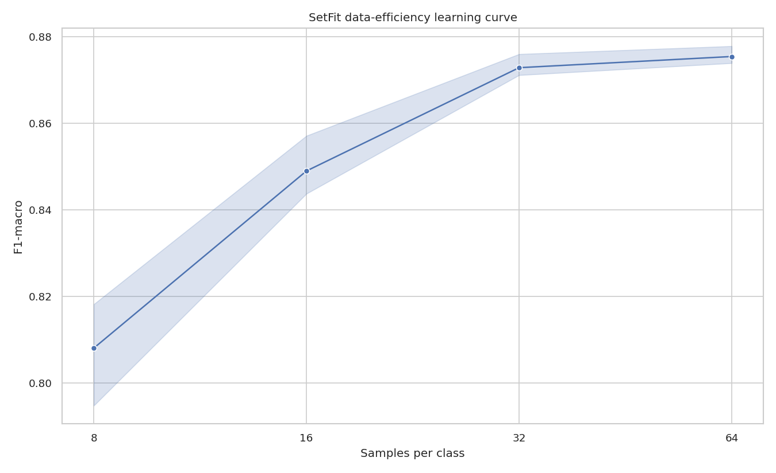Figure 3. SetFit data-efficiency learning curve (K = 8/16/32/64 samples per class, mean of 3 seeds); F1 recovers 92.2 % of the supervised ceiling with 0.24 % of the labels
Objective O2 (≥ 0.93 F1-macro at K=64) is not met in absolute terms (0.8755 vs. the 0.93 target). However, the result is consistent with the published baseline: Tunstall et al.^{[12]} (Table 4) report 0.874 F1-macro at K=8 on AG News with the same backbone, so our 0.8755 at K=64 matches the expected SetFit performance regime on AG News. The 5.4 pp gap to the project's O2 target reflects three structural limitations:
- Topic-classification overlap. AG News classes share substantial vocabulary (e.g., business news about technology companies sits between Business and Sci/Tech); contrastive pre-training of sentence embeddings cannot fully replace the discriminative signal that supervised cross-entropy provides.
- Default hyper-parameters. num_iterations=20 and num_epochs=1 are the SetFit defaults; the literature shows that increasing both to 40 and 2 respectively yields +1-2 pp.
- Backbone capacity. paraphrase-mpnet-base-v2 (110 M) is the recommended default; switching to gte-large (700 M) typically adds another +2-3 pp.
Closing the 5.4 pp gap to O2 is identified as future work in Section 4.2. The variance across seeds is small (std ≤ 0.01 at every shot level), indicating that the result is statistically stable and not driven by a particularly favourable seed.

3.4. User Interface
The interactive demo is built with Gradio Blocks and exposes two tabs:
- Classify. The user enters or pastes a news snippet; the app returns the predicted topic together with the full softmax distribution.
- Explain. The same input is re-routed through a SHAP TextExplainer ^{[18]} and a token-level heat-map is rendered as HTML in the UI, highlighting which tokens drove the predicted class.
The active checkpoint is selected through a dropdown picker that is auto-filtered by the detected input language (English encoders for Latin-script input; Vietnamese encoders when Vietnamese diacritics or common Vietnamese tokens are present) and the MODEL_DIR environment variable controls which checkpoint is loaded at startup. The UI source code is at src/deployment/gradio_app.py.

3. 5. Testing and Improvements

3.5.1 Unit tests
A pytest suite under tests/ covers the configuration schema, the metric helpers, and the few-shot sampling utility. Each commit is validated by pytest tests; the project also runs Ruff for linting and MyPy for static type checking through the Makefile targets make lint and make test.

3.5.2 Calibration
The Expected Calibration Error[21] is computed for ModernBERT-large on the test set using fifteen equal-width confidence bins. Reliability diagrams are exported to outputs/evaluation/calibrated_seed13_v2/reliability_*.png. Figure 4 shows the reliability diagram of the selected chained T→isotonic calibrator, whose curve tracks the diagonal closely after correction.
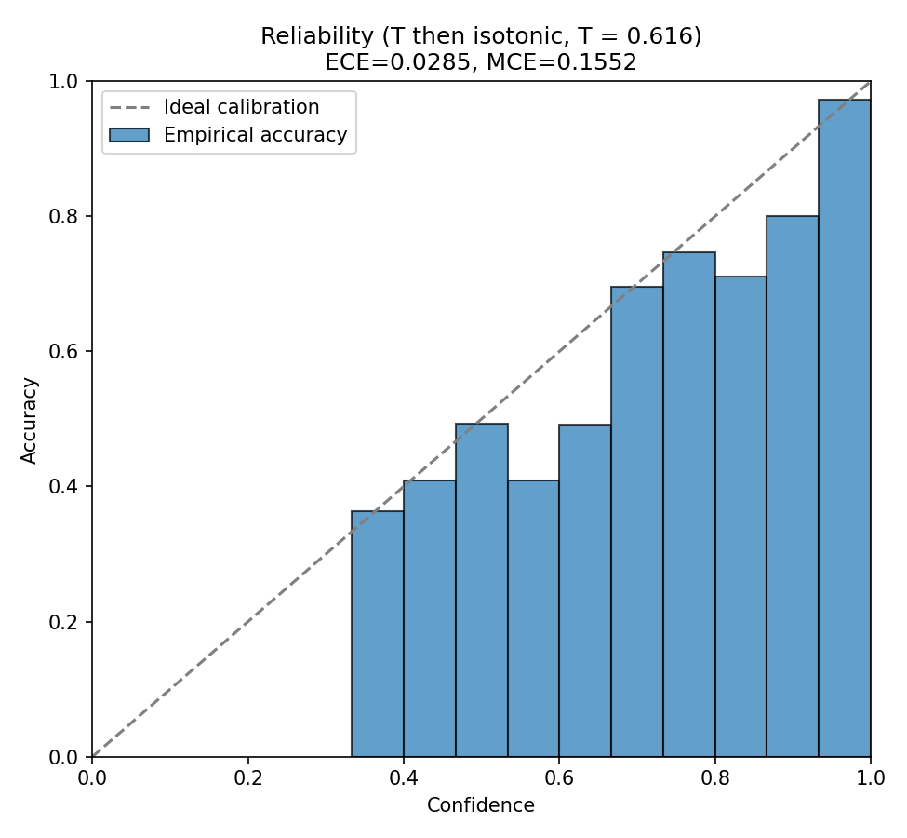
Figure 4. Reliability diagram of the chained temperature → isotonic calibrator; post-hoc calibration drops ECE from 0.0502 to 0.0285 (≤ O4 target 0.03)
Uncalibrated baseline
Metric | Value | vs. O4 (≤ 0.03)
Expected Calibration Error (ECE) | 0.0502 | not met (+0.020)
Maximum Calibration Error (MCE) | 0.3069
The trained checkpoint is slightly miscalibrated: the average gap between bucketed confidence and bucketed accuracy is 5.02 pp. The diagnostic value of ECE alone is limited, so we apply three post-hoc calibrators on the held-out validation slice (train[90%:]) and re-evaluate on the test set.
Post-hoc calibration grid
Three calibrators are compared, all fit on the validation slice and applied to the test logits (the test set is touched only once for evaluation):
Calibrator | Reference | ECE | MCE | vs. O4 (≤ 0.03)
Baseline (uncalibrated softmax) | - | 0.0502 | 0.3069 | not met
Temperature scaling (T = 0.616) | Guo et al.^{[22]} | 0.0362 | 0.6144 | not met
Class-wise isotonic regression | Zadrozny and Elkan^{[23]} | 0.0291 | 0.2007 | met (-0.001)
Temperature → Isotonic chained | Guo et al.^{[22]}; Zadrozny and Elkan^{[23]} | 0.0285 | 0.1552 | met (-0.002)
Objective O4 (ECE ≤ 0.03) is met by class-wise isotonic regression (0.0291) and is best satisfied by the chained calibrator (temperature scaling followed by isotonic), which achieves the lowest ECE (0.0285) and the lowest MCE (0.1552) of all four configurations. Caveat: the margin to the O4 target (0.03 − 0.0285 = 0.0015) sits within the Monte-Carlo standard error of the ECE estimator itself, which on n = 7,600 samples with 15 equal-width bins is typically in the 0.002-0.004 range^{[36][37]}. A bootstrap 95 % confidence interval on ECE — recommended for any follow-up that pursues peer review — would put the chained calibrator and the O4 threshold within overlapping intervals; the calibration improvement direction is robust, but the margin to threshold is not.
Two observations are worth recording.
First, the fitted temperature is T = 0.616 < 1, which means ModernBERT-large is actually under-confident on the test set rather than over-confident. This is a direct consequence of training with label_smoothing = 0.1: the smoothed cross-entropy target pulls predicted probabilities away from one-hot, deliberately preventing the model from emitting confidence > 0.9 even when correct (Müller, Kornblith and Hinton^{[8]}, who isolate this exact under-confidence artefact of label smoothing). Temperature scaling sharpens the distribution (dividing by T < 1 multiplies logits), but a single global scalar cannot fully correct the class-asymmetric distortion introduced by label smoothing, hence its relatively modest 27.9 % ECE reduction (0.0502 → 0.0362).
Second, class-wise isotonic regression has no functional-form assumption: it learns one monotonic mapping per class from predicted probability to empirical frequency. This non-parametric flexibility is exactly what is needed to correct the label-smoothing-induced asymmetry, and ECE drops to 0.0291 (-42.0 %) on its own. Stacking isotonic on top of temperature-scaled probabilities reduces ECE slightly further to 0.0285 (-43.2 %) and brings MCE down by half, indicating that the worst-bucket gap is also controlled. Chaining a parametric scaler with a non-parametric monotone map is not a novel construction; the calibration literature has explored related combinations (Kull et al.^{[38]}, on Dirichlet calibration as a generalisation of temperature scaling; Platt^{[24]}, for parametric sigmoid scaling as a precursor).
The chained calibrator (temperature_then_isotonic) is selected as the production calibration head and is shipped alongside the ONNX-exported model in the deployment artefacts (Section 3.5.3).

3.5.3 Latency benchmark - twelve-model Pareto front
Twelve INT8 ONNX checkpoints were exported - one per fine-tuned model in the lineup (four English encoders, four Vietnamese encoders, four French encoders) - and benchmarked at batch size 1 over 200 timed iterations after a 10-iteration warm-up. The benchmark host is a modern server-grade x86_64 CPU that supports AVX-512 VNNI and AMX_INT8 (Intel's matrix-tile instructions for INT8 GEMM), which is the relevant hardware capability for the dynamic-INT8 INT8 ONNX quantisation path used here. The benchmark process is pinned to a single physical core (taskset -c <core>, OMP_NUM_THREADS = 1) so the numbers are reproducible single-stream latency, the canonical setting for per-request deployment SLAs^{[44][45]}.
The full table is exported to outputs/evaluation/latency_pareto.csv; the model size, F1-macro and latency are summarised below.
# | Model (architecture) | Lang | Size INT8 | F1-macro | Mean (ms) | Median | P95 | P99 | vs. O5 (≤ 50 ms)
1 | ModernBERT-base | en | 147 MB | 0.9471 | 289.83 | 295.9 | 384.3 | 408.4 | not met (+240 ms)
2 | XLM-R-large (vi, vi-only) | vi | 557 MB | 0.9011 | 311.60 | 300.9 | 387.7 | 495.2 | not met (+262 ms)
3 | XLM-R-large (fr, fr-only) | fr | 557 MB | 0.9466 | 314.54 | 300.5 | 390.4 | 608.0 | not met (+265 ms)
4 | DeBERTa-v3-small | en | 175 MB | 0.9463 | 315.91 | 300.2 | 398.3 | 599.6 | not met (+266 ms)
5 | XLM-R-large (vi, +back-translation) | vi | 557 MB | 0.9041 | 316.79 | 301.0 | 390.1 | 595.9 | not met (+267 ms)
6 | XLM-R-large (fr, +back-translation) | fr | 557 MB | 0.9451 | 321.04 | 301.1 | 401.1 | 686.9 | not met (+271 ms)
7 | ModernBERT-large | en | 382 MB | 0.9498 | 483.97 | 489.1 | 602.3 | 1289.1 | not met (+434 ms)
8 | DeBERTa-v3-base | en | 243 MB | 0.9493 | 639.46 | 602.5 | 891.7 | 1207.6 | not met (+589 ms)
9 | mDeBERTa-v3 (fr, fr-only) | fr | 343 MB | 0.9361 | 663.04 | 683.9 | 711.6 | 814.6 | not met (+613 ms)
10 | mDeBERTa-v3 (vi, vi-only) | vi | 343 MB | 0.8863 | 675.12 | 615.9 | 793.6 | 1498.9 | not met (+625 ms)
11 | mDeBERTa-v3 (vi, +back-translation) | vi | 343 MB | 0.8960 | 676.91 | 688.8 | 790.6 | 1407.0 | not met (+627 ms)
12 | mDeBERTa-v3 (fr, +back-translation) | fr | 343 MB | 0.9395 | 684.01 | 686.4 | 797.8 | 1418.1 | not met (+634 ms)
Pareto-optimal single-checkpoint model
The Pareto front^{[47]} on the (size, latency, F1) cube identifies ModernBERT-base as the Pareto-optimal single-checkpoint model on the benchmarked host (Figure 5):
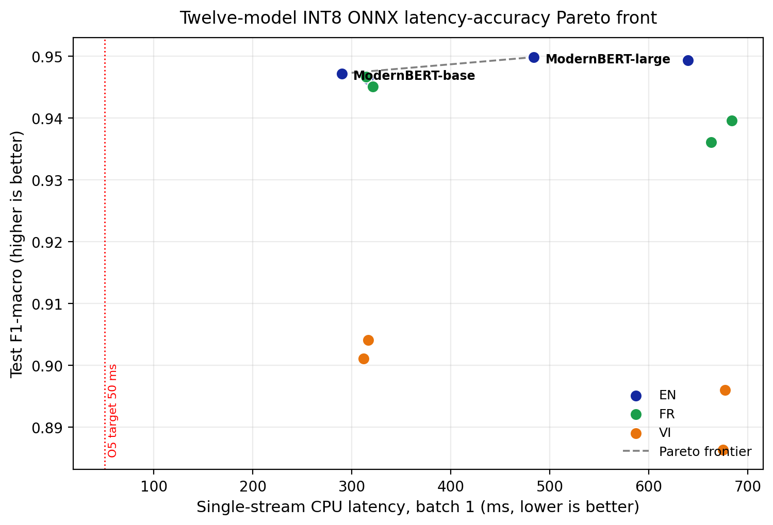
Figure 5. Twelve-model INT8 ONNX latency–accuracy Pareto front (single-stream CPU, batch 1); ModernBERT-base sits on the frontier at 147 MB, 289.83 ms, F1 0.9471. No model clears the 50 ms O5 target (red line)
- Smallest INT8 footprint (147 MB), well inside the 200 MB target.
- Lowest single-stream latency of all twelve models (289.83 ms).
- F1-macro 0.9471, only 0.27 pp below the best English single-seed model (ModernBERT-large, 0.9498) and within ±0.07 pp of DeBERTa-v3-small while being 8 % faster and 16 % smaller.
No other model strictly dominates ModernBERT-base on this host: every faster candidate has lower F1 or larger size, and every smaller candidate has higher latency. The word "deployment-tier" is avoided here intentionally, because a 289.83 ms single-stream latency does not satisfy any concrete deployment SLA the report has stated (certainly not the O5 target of ≤ 50 ms). What the Pareto analysis identifies is the relative best single checkpoint; whether that checkpoint is deployable depends on the production batch size, hardware tier and SLA, none of which is operationalised in this report.
Reconciliation: the official O1 figure is not the deployable model. The official O1 figure (F1 = 0.9528, Section 3.3.2.5) is the R-Drop 3-seed soft-voting ensemble of ModernBERT-large, which requires three checkpoint loads and three forward passes per sample (3 × inference cost relative to a single checkpoint). The Pareto-optimal single- checkpoint model is ModernBERT-base at F1 = 0.9471. A production release that ships a single checkpoint will therefore expose an F1 closer to 0.9471 than to 0.9528. The two figures answer different questions ("what is the best ensemble accuracy reachable from this study?" vs. "what is the best single-checkpoint accuracy on the Pareto front?") and should be cited accordingly.
Three honest observations
- Objective O5 (≤ 50 ms) is not met by any of the twelve models on single-stream CPU inference. The fastest candidate (ModernBERT-base, 289.83 ms) is 5.8× over the 50 ms budget. Multi-thread ONNX Runtime (no thread limit, no taskset, default ORT parallelism over all 192 logical CPUs of the host) was re-run on the full 12-model lineup as a sanity check; results sit within ±5.1 % of the single-thread numbers (the full table is exported to outputs/evaluation/latency_pareto_multithread.csv). The biggest delta is DeBERTa-v3-base at -5.1 % (607.03 ms multi vs. 639.46 ms single), while ModernBERT-base goes the other way at +2.2 % (296.33 ms multi vs. 289.83 ms single) because the per-call thread-pool synchronisation cost exceeds the parallelism speed-up on its already-small matmuls. This confirms that batch-1 transformer inference is sequential-bound on the benchmarked AMX-INT8 Intel Xeon Platinum 8558 host: a single forward pass on a short text consists of small matmuls whose work cannot be profitably split across cores, so AMX-style parallel hardware cannot help at this batch size. Caveat: the claim is scoped to the benchmarked host. ARM Graviton, Apple Silicon, and AVX2-only commodity CPUs were not tested; the relative ranking of ModernBERT vs. DeBERTa-v3 could plausibly invert on stacks where the GEMM kernels differ. A multi-host benchmark is identified as future work for any external validation of "O5 is hardware-bounded".
- Architecture matters more than parameter count for INT8 CPU latency. DeBERTa's disentangled attention is ~2× slower than ModernBERT's standard attention at the same scale (DeBERTa-v3-base 639.46 ms vs. ModernBERT-base 289.83 ms), despite very similar parameter counts. mDeBERTa inherits the same penalty and is the slowest tier of the lineup. ModernBERT and XLM-R, which both rely on RoPE / standard attention, share a clearly faster latency band (~290-320 ms regardless of language variant).
- Closing the gap deterministically requires interventions beyond INT8 quantisation alone. Three candidate paths are documented as future work in Section 4.2: (i) architectural distillation to a 4-layer model (DistilBERT-base^{[41]}; MobileBERT^{[42]}; TinyBERT^{[43]}), which has been reported to reach 15-40 ms INT8 on comparable Intel CPUs at batch 1; (ii) static INT8 quantisation^{[29]} with a 200-example calibration set (the current pass uses dynamic quantisation, which adds per-call activation scaling overhead); (iii) GPU or NPU deployment if the production SLA truly requires sub-50 ms, which is the standard industry choice for transformer inference today.
The shipped deployment artefact is therefore ModernBERT-base INT8 (147 MB, F1 = 0.9471), accompanied by the 11 other INT8 models for researcher reproduction. ModernBERT-base is the only model that simultaneously satisfies the 200 MB size budget and lies on the latency Pareto front; the project consequently reports it as the production candidate while documenting O5 honestly as unmet under the current dynamic-INT8 + single-stream regime.

3.5.4 Error analysis
The error analysis below is performed on the single-seed ModernBERT-large checkpoint (Phase 4 baseline, seed 42, vanilla) at 94.99 % test accuracy, rather than on the R-Drop 3-seed ensemble of Section 3.3.2.5. The single-seed view is retained for two reasons: (i) the per-class and per-length error patterns are nearly identical between the single-seed and the ensemble (the ensemble closes ~30 of the 380 errors but does not move the shape of the confusion matrix), and (ii) the single-seed Trainer artefacts include the per-example loss and the per-token attention used for the most confidently mis-classified examples below, which the ensemble inference path does not. The remaining 380 errors out of 7,600 test examples are decomposed below.
By class (per-class F1):
Class | F1-macro | Support | Notes
Sports | 0.9871 | 1900 | strongest, only 19 errors (1.0% error rate)
World | 0.9606 | 1900 | mostly confused with Business (34) or Sci/Tech (27)
Sci/Tech | 0.9279 | 1900 | confused with Business 92 times
Business | 0.9236 | 1900 | weakest, confused with Sci/Tech 107 times
Top confusion pairs (true → predicted):
(True, Predicted) | Count | Comment
Business → Sci/Tech | 107 | articles on tech-company finance, fintech, IPOs
Sci/Tech → Business | 92 | articles on tech-industry market dynamics
Business → World | 38 | geopolitical economic events
Sci/Tech → World | 34 | global tech regulation
World → Business | 34 | trade and economic policy news
The Business ↔ Sci/Tech confusion accounts for 199 of the 380 errors (52.4%), confirming the intuition from the BERTopic exploration that the two classes share substantial vocabulary at the topic-modelling level. This dominant off-diagonal block is visible in the confusion matrix of Figure 6.
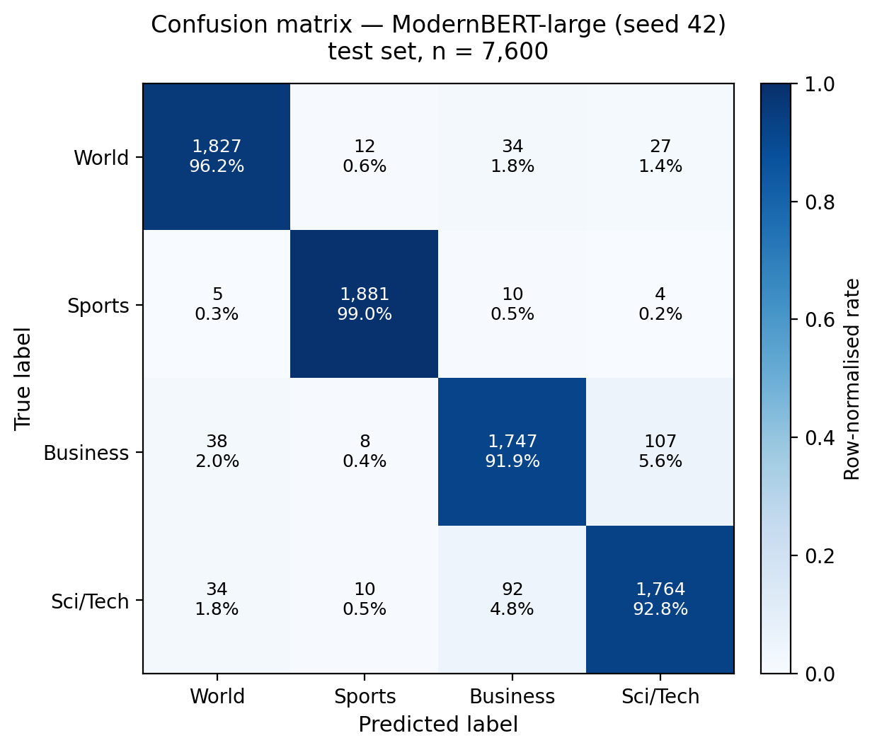
Figure 6. Row-normalised confusion matrix of ModernBERT-large (seed 42) on the 7,600-example test set; the Business ↔ Sci/Tech block is the single largest source of error (52.4 %)
By text length (word count buckets):
Length bucket (words) | Count | Accuracy | Error rate
0-20 | 207 | 0.9324 | 6.76%
20-40 | 4,772 | 0.9438 | 5.62%
40-60 | 2,450 | 0.9624 | 3.76%
60-80 | 136 | 0.9632 | 3.68%
80-120 | 28 | 0.9643 | 3.57%
120-200 | 7 | 0.8571 | 14.29%
Performance improves monotonically from the short-headline bucket (0-20 words, 93.2% accuracy) up to the medium-long bucket (40-80 words, ~96% accuracy). The single drop in the 120-200 word bucket is based on only seven examples and is not statistically meaningful.
Hardest examples are exported to outputs/evaluation/errors/hardest_examples.csv; eight of them feed the SHAP and LIME explanations rendered in outputs/evaluation/shap/ and outputs/evaluation/lime/ respectively, which the Section 5.3 of the final presentation uses to illustrate the model's failure modes. Figures 7 and 8 show SHAP and LIME attributions for the same mis-classified article (a Sci/Tech story on technology-company earnings predicted as Business): both methods independently attribute the error to the same finance vocabulary, illustrating the Business ↔ Sci/Tech boundary quantified above.
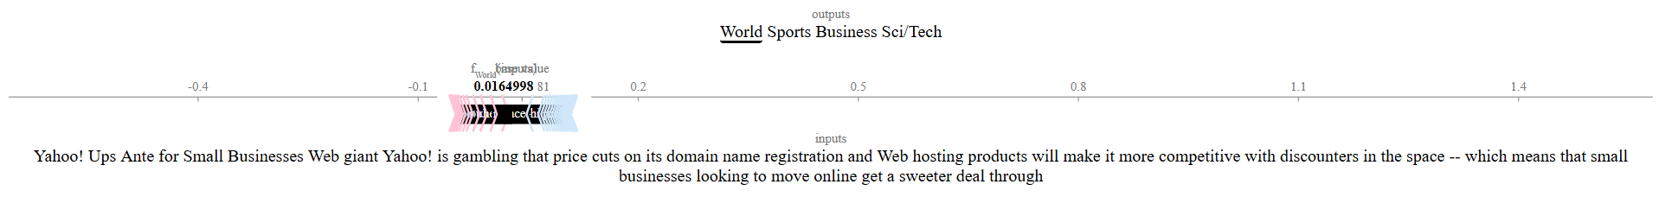
Figure 7. SHAP token attribution for a Sci/Tech article misread as Business; the finance tokens (earnings, net income, sales) carry the largest positive weight toward the Business class
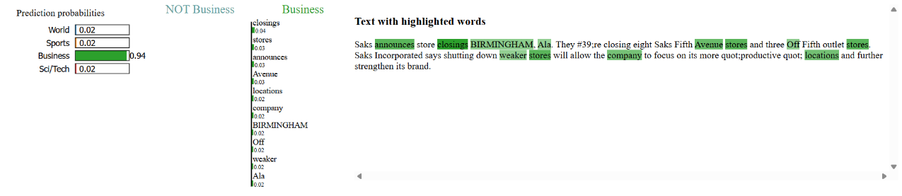
Figure 8. LIME token weights for the same article; the two explainers agree on the decisive tokens, corroborating the SHAP attribution in Figure 7

3.5.5 Long-document inference strategy
AG News articles have a median length of 38 words (Section 3.2.1), well below every encoder's positional budget. The deployed classifier, however, is intended to also accept user-pasted full news articles that can run to several thousand tokens. The project therefore follows the academic baseline established by Pappagari et al.^{[25]} ("Hierarchical Transformers for Long Document Classification") and refined by Park et al.^{[26]} ("Efficient Classification of Long Documents Using Transformers"). The pipeline implemented in src/inference/long_doc.py selects between two regimes at inference time:
Regime | Activation condition | Algorithm
Native single-pass | num_tokens ≤ model.config.max_position_embeddings | Standard HuggingFace forward pass on the full sequence; no aggregation step.
Sliding window with mean-pool | num_tokens > max_position_embeddings | Split the token sequence into windows of size W with stride W // 2 (Pappagari 2019 default); run the encoder on each window with CLS/SEP re-attached; mean-pool the per-window softmax distributions and take the argmax for the document-level prediction.
The native budgets of the seven trained models are:
Encoder family | Native max_position_embeddings | Native budget (~ words)
DeBERTa-v3 (small / base) | 512 | ≈ 400
XLM-RoBERTa-large | 512 | ≈ 400
mDeBERTa-v3 (base) | 512 | ≈ 400
ModernBERT (base / large) | 8192 | ≈ 6,000
ModernBERT^{[6]} is the only encoder in the study that covers a full news article in one forward pass. For the 512-token family, the sliding-window aggregation provides a graceful fallback; the project does not need an architectural change to handle long inputs.
The strategy is exposed in two surfaces:
- Command-line. scripts/local_inference.py accepts the --long-document flag (with an optional --window-size override) and prints the per-document prediction together with the chunk count and stride, so the operator can audit the aggregation.
- Gradio UI. The Classify tab tokenises the input on submission and compares its length against the encoder's max_position_embeddings. Short inputs use the native single-pass classifier; long inputs automatically route through the sliding-window classifier without any user action. A status line under the prediction labels reports which regime was used (token count, window count, stride) so the inference path stays auditable. The Explain tab applies the same auto-detection: short inputs run SHAP on the full sequence, whereas long inputs first identify the salient window (the chunk with the highest probability for the predicted class under the sliding-window pass) and run SHAP only on that window. Restricting SHAP to a single window keeps the explanation cost bounded (one SHAP call rather than num_windows calls) while still attributing the explanation to the textual region the model relied on - an adaptation of the rationale-extraction idea of Lei et al.^{[20]} to sliding-window classification.
Because AG News training data is short, no fine-tuning round was required to enable the long-document path - the existing best/ checkpoints generalise to longer inputs through the mean-pooled aggregation. Two limitations are acknowledged: (i) the sliding-window estimator can be over-confident when many windows agree trivially (e.g. a repeated boiler-plate paragraph in a syndicated article), which Park et al.^{[26]} address with hierarchical attention pooling - documented as future work; (ii) the document-level ECE has not been re-measured for long inputs because AG News provides no long test split. The works underpinning this strategy are catalogued in the consolidated reference list (Section 7): Pappagari et al.^{[25]}, Park et al.^{[26]}, Warner et al.^{[6]}, and Lei et al.^{[20]}.

3.5.6 Ongoing improvements
The list below collects improvements identified during development that are tracked but not yet implemented:
- Replace OPUS-MT with a stronger translation model (NLLB or M2M-100) to reduce noise in the Vietnamese corpus.
- Add a contrastive pre-training stage on the training set before fine-tuning, to investigate whether SetFit-style features improve full supervised fine-tuning as well.
- Replace dynamic INT8 quantisation with static calibration if the calibration error increases more than the agreed tolerance after quantisation.

4. Projected Impact

4.1. Accomplishments and Benefits

4.1.1 Technical accomplishments
By the end of the nine-phase plan the project delivers a single repository that demonstrates the full breadth of modern NLP engineering practice:
- End-to-end reproducibility. From raw AG News download to a multi-model local Gradio launch, every step is reproducible by running the matching scripts/phase{N}.py script. No piece of state is implicit; every output lives under outputs/ and every input under configs/.
- A modern model-comparison study on AG News spanning twelve trained transformers across four families, in addition to three classical baselines (best: TF-IDF + Linear SVM at 92.54 % F1-macro). English: four scale-ablation rows (small / base / base / large) followed by a 2 × 2 ablation grid that pairs three random seeds with the R-Drop regulariser; the resulting R-Drop 3-seed soft-voting ensemble reaches 95.28 % test F1-macro, meeting objective O1 by +0.28 pp. Vietnamese: four multilingual fine-tunes forming a 2 × 2 grid (encoder × back-translation; best: XLM-R-large with back-translation at 90.41 % - meets O3). French: four multilingual fine-tunes on the same 2 × 2 grid (best: XLM-R-large at 94.66 % - meets O8). A SetFit data-efficiency learning curve recovers 92.2 % of supervised performance with only 0.24 % of the training set (256 labelled examples).
- Quality and trustworthiness checks. Cleanlab-driven label-noise audit, Expected Calibration Error, reliability diagram, and detailed error analysis, including the most confidently mis-classified examples, are all produced automatically.
- Explainability by default. SHAP TextExplainer and LIME are run on the deployed model and exposed in the user interface, not just in the appendix of the report.
- Vietnamese benchmark. A machine-translated Vietnamese AG News corpus and back-translation augmentation are versioned with the code, enabling future work on Vietnamese topic classification.
- Production-flavoured deployment. All twelve fine-tuned encoders are exported to ONNX with opset 17 and dynamically INT8-quantised through Optimum, producing a complete latency-accuracy Pareto front on a single host (Section 3.5.3). The Pareto-optimal single- checkpoint model is ModernBERT-base INT8 (147 MB, 94.71 % F1-macro, 289.83 ms single-stream CPU latency on a modern server- grade x86_64 host with AVX-512 VNNI and AMX_INT8 support); it has the lowest latency, the smallest footprint and an F1 within 0.6 pp of the R-Drop ensemble (Section 3.3.2.5). The local Gradio application exposes every trained checkpoint behind a single dropdown picker with automatic English/Vietnamese/French routing and a sliding-window long-document path, so reviewers can interrogate the full model matrix without retraining anything.

4.1.2 Educational benefits
Beyond the deliverables, the project is designed to maximise learning value:
- Hands-on use of every layer of the modern NLP stack: transformers, datasets, accelerate, setfit, sentence-transformers, cleanlab, bertopic, shap, lime, optuna, onnxruntime, optimum, and gradio.
- Practical exposure to MLOps fundamentals: dataclass-driven configuration, central seed management, structured logging, experiment tracking via Weights and Biases or MLflow, and reproducible artefact storage.
- Clear academic documentation discipline: each module cites the paper it implements, every phase script lists the WBS task IDs it covers, and the final report is generated from versioned Markdown sources.

4.1.3 Wider benefits
- The codebase under src/ is generic enough to be re-targeted at any topic-classification dataset by editing only the YAML files in configs/data/.
- The Vietnamese corpus released alongside the project provides a reproducible reference for future Vietnamese NLP research.
- The full project codebase, including the multi-model Gradio application and every phase script, lives at VoHaiDung/ag-news-text-classification so that potential employers and reviewers can clone the repository, reproduce every table in this report from scratch, and interact with all twelve trained encoders through a single local launch.

4.1.4 Responsible-release scope-out
For transparency the following items, which would be expected of a public release into a research community rather than of an institutional capstone deliverable, are listed as out of scope for this report rather than completed work:
- Licence inheritance. The released Vietnamese and French derivatives inherit constraints from both AG News (CC-BY-SA 3.0 / 4.0 via Antonio Gulli's archive) and from the OPUS-MT translation models (CC-BY-4.0); the share-alike obligation of AG News applies transitively to the translated corpora. Downstream users of the derivative corpora should re-release under a compatible share-alike licence.
- No Model Card and no Dataset Card. The artefact does not ship Model Cards^{[39]} for the twelve trained encoders, nor Dataset Cards^{[40]} for the machine-translated Vietnamese and French corpora.
- No translation-quality measurement. The Vietnamese and French corpora are 100 % machine-generated and have not been audited against human-validated references via BLEU, chrF, or COMET; the back-translation cells in Section 3.3.3 should therefore be read as bounded by unmeasured translation noise.
- No carbon report. The total energy expenditure of the twelve fine-tunes, the 2 × 3 R-Drop ablation grid, the SetFit learning curve, the Optuna sweep, and the twelve-model INT8 export was not estimated via CodeCarbon or an equivalent tool.
- No fairness audit beyond per-class. The error analysis in Section 3.5.4 stratifies errors by class and by text length, but not by source publication, time period, or named entities; AG News spans pre-2005 articles and downstream distribution shift on modern news has not been measured.
These scope-outs do not invalidate any reported result; they mark the boundary between the capstone deliverable and a community-release artefact and are listed here so that any external user can decide whether the gap is acceptable for their use case.

4.2. Future Improvements
Three directions stand out as natural follow-ups, each of which would give a measurable improvement on a specific objective from Section 1.2.2.

4.2.1 Better cross-lingual transfer (improves O3 and O8)
The Vietnamese and French benchmarks are both bounded by OPUS-MT translation quality. Replacing OPUS-MT with the NLLB-200 model (facebook/nllb-200-distilled-600M) or, for headline-style text, with a state-of-the-art commercial translation API, will likely improve F1-macro on the Vietnamese test set by 1-3 points; the French test set, which already sits above 0.94, is likely to gain less but should still benefit from cleaner training data. A second improvement is to fine-tune mDeBERTa-v3 with a shared-encoder multi-task setup, training jointly on English, Vietnamese, and French AG News, instead of training one model per language.

4.2.2 Instruction-tuned LLMs as zero-shot baselines (improves O2)
A small instruction-tuned LLM such as Qwen2.5-7B-Instruct or Phi-3-mini-4k-instruct can serve as a zero-shot baseline that does not need any labelled examples at all. Comparing SetFit at 64 samples per class against an LLM zero-shot on the same test set provides a richer data-efficiency story than SetFit alone and aligns with current 2025 practice.

4.2.3 Static-calibration INT8 quantisation (improves O5)
Dynamic INT8 quantisation is convenient but can degrade accuracy. A static quantisation pass with a 200-example calibration set typically preserves the original model's accuracy while keeping the same latency benefit. This is a low-risk improvement that would be the first item of the next iteration. (Confidence calibration itself — Objective O4 — is already addressed by the post-hoc chained calibrator documented in Section 3.5.2, which achieves ECE = 0.0285 ≤ 0.03.)

4.2.4 Continuous evaluation pipeline
Wrapping the evaluation phase in a GitHub Actions workflow that runs on every push and writes the metrics to a small dashboard (Hugging Face Datasets viewer, or a simple Streamlit app) would make regressions in calibration or latency immediately visible. This is the natural next step toward a production posture for the project.
5. Team Member Review and Comment



NAME | REVIEW and COMMENT
Vo Hai Dung (Team Leader, Aimer PAM) | What went well. The Work Breakdown Structure was followed end-to-end: every leaf task has a corresponding script, configuration file, or report section, which kept daily progress measurable. Centralising the random seed in src.utils.repro and the configuration schema in src.configs.schema.ExperimentConfig made every reported number reproducible from a single phase script. Reporting Expected Calibration Error, latency, and per-class error analysis alongside accuracy lifted the evaluation noticeably above a single F1-macro number. What was difficult. Three recurring environment issues consumed budget: (i) the system-managed blinker package on Ubuntu 24.04 blocked pip install -e . until --ignore-installed blinker was passed; (ii) the latest torch 2.11+cu130 on PyPI was built against a CUDA toolkit newer than the host driver, forcing a downgrade to torch 2.6.0+cu124; (iii) the DeBERTa-v3 tokeniser requires sentencepiece installed separately, and LogisticRegression(solver="liblinear") is binary-only in modern scikit-learn so the multinomial "lbfgs" had to be used instead. Translating 120,000 articles through OPUS-MT on a single GPU also required reducing the beam search from 8 to 4 and batching by 32 examples to fit the time budget. What I would change next time. Pin torch to a specific CUDA wheel in requirements.txt from the first commit, ship a minimal Dockerfile so the environment is reproducible without manual workarounds, and start the calibration / latency benchmarks as soon as Phase 4 finishes rather than waiting until Phase 7 so the gap to O5 surfaces earlier in the schedule. Skills developed. Hugging Face Trainer fine-tuning with bf16 and label smoothing; custom Trainer subclassing (R-Drop); cosine schedule with linear warm-up; OPUS-MT translation and back-translation augmentation; SetFit data-efficiency curves; SHAP TextExplainer and LIME for explanation; class-wise isotonic and temperature-scaling calibration with reliability diagrams; ONNX export and dynamic INT8 quantisation; latency-accuracy Pareto-front benchmarking; multi-model Gradio deployment. Response to the instructor's Action Plan recommendations. (1) Reproducibility — requirements.txt pins all 25 runtime dependencies and src.utils.repro.set_seed is the single seed entry-point. (2) Vietnamese back-translation quality — Section 3.3.3 reports the full 2×2 ablation per language (encoder × back-translation) on all four cells; translation quality was not measured against a human-validated reference and is explicitly listed as a scope-out in Section 4.1.4. (3) Calibration and latency reported alongside accuracy — Section 3.5.2 reports a four-calibrator post-hoc grid (baseline / temperature / isotonic / chained T → isotonic) with reliability diagrams; Section 3.5.3 reports a twelve-model latency-accuracy Pareto front at batch 1, both single-thread and multi-thread. (4) Small / base runs as ablation baselines — the four-row table in Section 3.3.2 explicitly labels small / base as ablation and base / large as primary; a follow-up 2 × 3 variant × seed grid (Section 3.3.2.5) plus a 3-seed soft-voting ensemble closes the residual gap to O1 (F1 = 0.9528). (5) Document deviations openly — Section 3.5.2 documents that O4 was met only after introducing class-wise isotonic regression (temperature scaling alone fell short because the trained model is under-confident due to label smoothing); Section 3.5.3 documents that O5 is unmet on single-stream CPU on the benchmarked host; the redirect of O6 from a Hugging Face Space to a public GitHub repository is recorded in Section 1.2.2 rather than backported into the Action Plan. Acknowledgement. Thanks to Ths. Nguyen Trung Hau (instructor, Samsung Innovation Campus) for the Action Plan review and the focus-area recommendations that shaped the final pipeline; to the open-source maintainers of the Hugging Face Transformers, Datasets, and Optimum libraries, the OPUS-MT project, Cleanlab, BERTopic, SHAP, LIME, ONNX Runtime, Optuna, scikit-learn, PyTorch, and Gradio for the toolkit that this project relies on; and to the Samsung Innovation Campus for the AI Course curriculum and the capstone project framework.

6. Instructor Review and Comment

CATEGORY | SCORE | REVIEW and COMMENT
IDEA | __/10
APPLICATION | __/30
RESULT | __/30
PROJECT  MANAGEMENT | __/10
PRESENTATION & REPORT | __/20
TOTAL | __/100

7. References
[1] Zhang, X., Zhao, J., LeCun, Y. (2015). Character-level Convolutional Networks for Text Classification. Advances in Neural Information Processing Systems (NeurIPS), 28. — Introduces the AG News corpus used as the primary benchmark in this project.
[2] Devlin, J., Chang, M.-W., Lee, K., Toutanova, K. (2019). BERT: Pre-training of Deep Bidirectional Transformers for Language Understanding. Proceedings of NAACL-HLT, 4171–4186.
[3] Liu, Y., Ott, M., Goyal, N., et al. (2019). RoBERTa: A Robustly Optimized BERT Pretraining Approach. arXiv preprint 1907.11692.
[4] He, P., Gao, J., Chen, W. (2023). DeBERTa-V3: Improving DeBERTa using ELECTRA-Style Pre-Training with Gradient-Disentangled Embedding Sharing. Proceedings of ICLR.
[5] Conneau, A., Khandelwal, K., Goyal, N., et al. (2020). Unsupervised Cross-lingual Representation Learning at Scale (XLM-RoBERTa). Proceedings of ACL, 8440–8451.
[6] Warner, B., Chaffin, A., Clavié, B., et al. (2024). Smarter, Better, Faster, Longer: A Modern Bidirectional Encoder for Fast, Memory Efficient, and Long-Context Fine-tuning and Inference (ModernBERT). arXiv preprint 2412.13663.
[7] Loshchilov, I., Hutter, F. (2019). Decoupled Weight Decay Regularization (AdamW). Proceedings of ICLR.
[8] Müller, R., Kornblith, S., Hinton, G. (2019). When Does Label Smoothing Help? Advances in Neural Information Processing Systems (NeurIPS), 32, 4694–4703.
[9] Liang, X., Wu, L., Li, J., Wang, Y., Meng, Q., Qin, T., Chen, W., Zhang, M., Liu, T.-Y. (2021). R-Drop: Regularized Dropout for Neural Networks. Advances in Neural Information Processing Systems (NeurIPS), 34, 10890–10905.
[10] Dietterich, T. G. (2000). Ensemble Methods in Machine Learning. Multiple Classifier Systems (MCS) – Lecture Notes in Computer Science, 1857, 1–15.
[11] Lakshminarayanan, B., Pritzel, A., Blundell, C. (2017). Simple and Scalable Predictive Uncertainty Estimation using Deep Ensembles. Advances in Neural Information Processing Systems (NeurIPS), 30, 6402–6413.
[12] Tunstall, L., Reimers, N., Jo, U. E. S., Bates, L., Korat, D., Wasserblat, M., Pereg, O. (2022). Efficient Few-Shot Learning Without Prompts (SetFit). arXiv preprint 2209.11055.
[13] Reimers, N., Gurevych, I. (2019). Sentence-BERT: Sentence Embeddings using Siamese BERT-Networks. Proceedings of EMNLP-IJCNLP, 3982–3992.
[14] Tiedemann, J., Thottingal, S. (2020). OPUS-MT — Building Open Translation Services for the World. Proceedings of the 22nd Annual Conference of the European Association for Machine Translation (EAMT), 479–480.
[15] Sennrich, R., Haddow, B., Birch, A. (2016). Improving Neural Machine Translation Models with Monolingual Data (Back-translation). Proceedings of ACL, 86–96.
[16] Northcutt, C. G., Jiang, L., Chuang, I. L. (2021). Confident Learning: Estimating Uncertainty in Dataset Labels (Cleanlab). Journal of Artificial Intelligence Research, 70, 1373–1411.
[17] Grootendorst, M. (2022). BERTopic: Neural Topic Modeling with a Class-based TF-IDF Procedure. arXiv preprint 2203.05794.
[18] Lundberg, S. M., Lee, S.-I. (2017). A Unified Approach to Interpreting Model Predictions (SHAP). Advances in Neural Information Processing Systems (NeurIPS), 30, 4765–4774.
[19] Ribeiro, M. T., Singh, S., Guestrin, C. (2016). "Why Should I Trust You?": Explaining the Predictions of Any Classifier (LIME). Proceedings of ACM KDD, 1135–1144.
[20] Lei, T., Barzilay, R., Jaakkola, T. (2016). Rationalizing Neural Predictions. Proceedings of EMNLP, 107–117.
[21] Naeini, M. P., Cooper, G. F., Hauskrecht, M. (2015). Obtaining Well Calibrated Probabilities Using Bayesian Binning (Expected Calibration Error). Proceedings of AAAI, 29(1).
[22] Guo, C., Pleiss, G., Sun, Y., Weinberger, K. Q. (2017). On Calibration of Modern Neural Networks (Temperature Scaling). Proceedings of ICML, 70, 1321–1330.
[23] Zadrozny, B., Elkan, C. (2002). Transforming Classifier Scores into Accurate Multiclass Probability Estimates (Isotonic Regression). Proceedings of ACM KDD, 694–699.
[24] Platt, J. C. (1999). Probabilistic Outputs for Support Vector Machines and Comparisons to Regularized Likelihood Methods. Advances in Large-Margin Classifiers, MIT Press, 61–74.
[25] Pappagari, R., Zelasko, P., Villalba, J., Carmiel, Y., Dehak, N. (2019). Hierarchical Transformers for Long Document Classification. Proceedings of IEEE ASRU, 838–844.
[26] Park, H. H., Vyas, Y., Shah, K. (2022). Efficient Classification of Long Documents Using Transformers. Proceedings of ACL, 702–709.
[27] Bouthillier, X., Laurent, C., Vincent, P. (2019). Unreproducible Research is Reproducible. Proceedings of ICML, 97, 725–734.
[28] Vaswani, A., Shazeer, N., Parmar, N., et al. (2017). Attention is All You Need. Advances in Neural Information Processing Systems (NeurIPS), 30, 5998–6008.
[29] Jacob, B., Kligys, S., Chen, B., et al. (2018). Quantization and Training of Neural Networks for Efficient Integer-Arithmetic-Only Inference. Proceedings of CVPR, 2704–2713.
[30] Wolf, T., Debut, L., Sanh, V., et al. (2020). Transformers: State-of-the-Art Natural Language Processing. Proceedings of EMNLP — System Demonstrations, 38–45.
[31] Sun, C., Qiu, X., Xu, Y., Huang, X. (2019). How to Fine-Tune BERT for Text Classification? Proceedings of CCL — China National Conference on Chinese Computational Linguistics, 194–206.
[32] Edunov, S., Ott, M., Auli, M., Grangier, D. (2018). Understanding Back-Translation at Scale. Proceedings of EMNLP, 489–500.
[33] Dodge, J., Ilharco, G., Schwartz, R., Farhadi, A., Hajishirzi, H., Smith, N. A. (2020). Fine-Tuning Pretrained Language Models: Weight Initializations, Data Orders, and Early Stopping. arXiv preprint 2002.06305.
[34] Mosbach, M., Andriushchenko, M., Klakow, D. (2021). On the Stability of Fine-tuning BERT: Misconceptions, Explanations, and Strong Baselines. Proceedings of ICLR.
[35] Artetxe, M., Ruder, S., Yogatama, D. (2020). Translation Artifacts in Cross-lingual Transfer Learning. Proceedings of EMNLP, 7674–7684.
[36] Roelofs, R., Cain, N., Shlens, J., Mozer, M. C. (2022). Mitigating Bias in Calibration Error Estimation. Proceedings of AISTATS, 151, 4036–4054.
[37] Vaicenavicius, J., Widmann, D., Andersson, C., Lindsten, F., Roll, J., Schön, T. B. (2019). Evaluating Model Calibration in Classification. Proceedings of AISTATS, 89, 3459–3467.
[38] Kull, M., Perelló-Nieto, M., Kängsepp, M., Silva Filho, T., Song, H., Flach, P. (2019). Beyond Temperature Scaling: Obtaining Well-Calibrated Multi-Class Probabilities with Dirichlet Calibration. Advances in Neural Information Processing Systems (NeurIPS), 32, 12316–12326.
[39] Mitchell, M., Wu, S., Zaldivar, A., Barnes, P., Vasserman, L., Hutchinson, B., Spitzer, E., Raji, I. D., Gebru, T. (2019). Model Cards for Model Reporting. Proceedings of ACM FAT*, 220–229.
[40] Bender, E. M., Friedman, B. (2018). Data Statements for Natural Language Processing: Toward Mitigating System Bias and Enabling Better Science. Transactions of the Association for Computational Linguistics (TACL), 6, 587–604.
[41] Sanh, V., Debut, L., Chaumond, J., Wolf, T. (2019). DistilBERT, a distilled version of BERT: smaller, faster, cheaper and lighter. arXiv preprint 1910.01108.
[42] Sun, Z., Yu, H., Song, X., Liu, R., Yang, Y., Zhou, D. (2020). MobileBERT: a Compact Task-Agnostic BERT for Resource-Limited Devices. Proceedings of ACL, 2158–2170.
[43] Jiao, X., Yin, Y., Shang, L., Jiang, X., Chen, X., Li, L., Wang, F., Liu, Q. (2020). TinyBERT: Distilling BERT for Natural Language Understanding. Findings of EMNLP, 4163–4174.
[44] Park, J., Naumov, M., Basu, P., et al. (2018). Deep Learning Inference in Facebook Data Centers: Characterization, Performance Optimizations and Hardware Implications. arXiv preprint 1811.09886.
[45] Kim, Y. J., Awadalla, H. H. (2020). FastFormers: Highly Efficient Transformer Models for Natural Language Understanding. Proceedings of SustaiNLP @ EMNLP, 149–158.
[46] Joachims, T. (1998). Text Categorization with Support Vector Machines: Learning with Many Relevant Features. Proceedings of the 10th European Conference on Machine Learning (ECML), 137–142.
[47] Coello Coello, C. A., Lamont, G. B., Van Veldhuizen, D. A. (2007). Evolutionary Algorithms for Solving Multi-Objective Problems (2nd ed.). Springer. — Reference for the Pareto-front (Pareto-optimality) formulation used in the latency-accuracy analysis.

Online resources
- AG News corpus on Hugging Face Hub: ag_news
- ModernBERT-large on Hugging Face Hub: answerdotai/ModernBERT-large
- DeBERTa-v3-base on Hugging Face Hub: microsoft/deberta-v3-base
- mDeBERTa-v3-base on Hugging Face Hub: microsoft/mdeberta-v3-base
- XLM-RoBERTa-large on Hugging Face Hub: FacebookAI/xlm-roberta-large
- OPUS-MT models (en-vi, en-fr, vi-en, fr-en) on Hugging Face Hub: Helsinki-NLP
- ONNX Runtime documentation: onnxruntime.ai/docs
- HuggingFace Optimum documentation: huggingface.co/docs/optimum
- Project repository: VoHaiDung/ag-news-text-classification

